Jasmine Wiggley
Washington University of St. Louis
Risa 3D
Analysis of a Stable Structural Frame

Analysis of a Stable Structural Frame

Procedure:
Complete a stable structure in Risa 3D. Give the output of the structure and compare the results to my handwritten calculations.

Results:
Tables 1 and 2 provide the joint coordinate and member data to complete my structural model. Figure 1 is the result of the combination of data in Table 1 and Table 2.
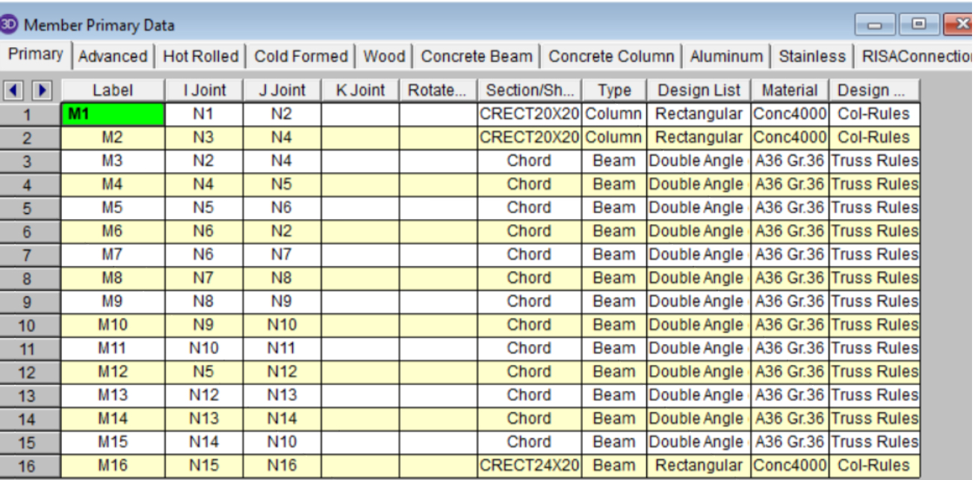
Table 1: Includes data for each member
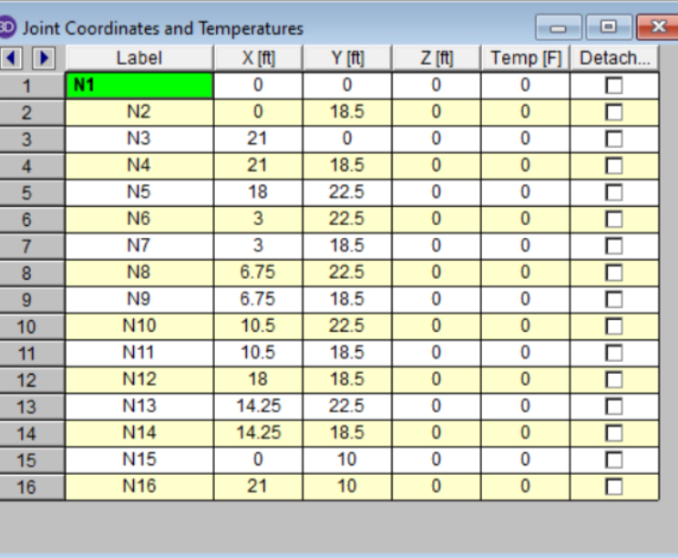
Table 2: Includes the exact joint coordinates in order to create Figure 1
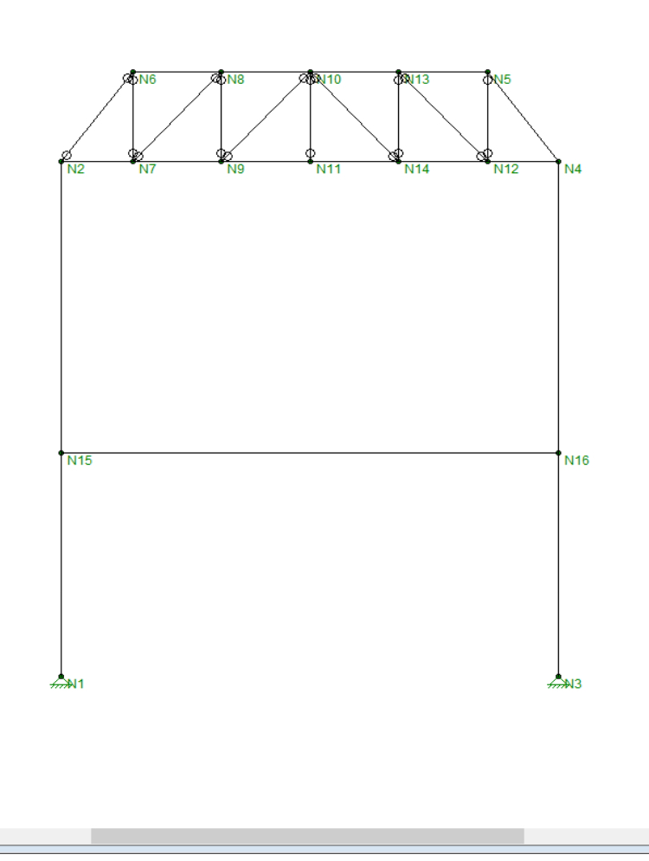
Figure 1: The model that is the result of tables 1 and 2 data

Conclusion:
I was successful in creating this model as there weren’t any discrepancies in regards to data input. Which thereby helped me to create a stable model in Risa 3D that also matched my handwritten calculations. Stability and safety are very important as a structural engineer. My goal was achieved.

